Submitting a claim for reimbursement with TASC

- Log in:
- https://www.tasconline.com/
- Click on the green LOG IN button on the top right > Select individual/employee

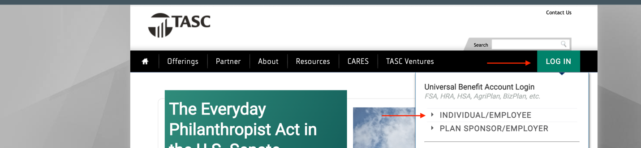

- Enter the email address and password you used when you signed up. If you haven’t signed up, click on sign up link. You can also view the video they have for instructions if you need help signing up. (see screen shot below)

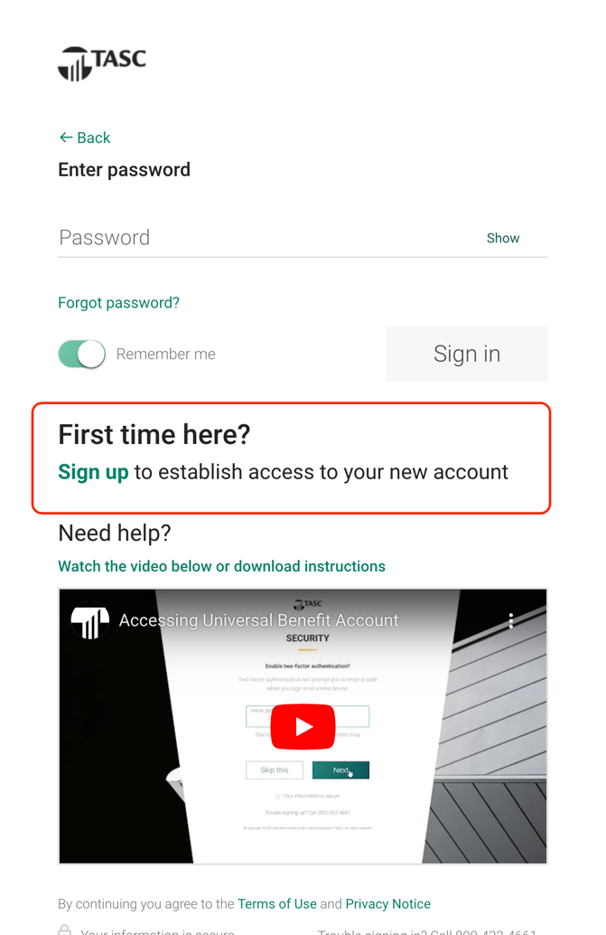

- Once you log on – you’ll be able to view your Healthcare FSA 2021 balance (if any) and your Healthcare FSA balance for 2022. (See screen shot below)

- To request a reimbursement for expenses incurred in 2021, please click on ‘Request a reimbursement’ to start the process. The deadline to request reimbursement for 2021 expenses is March 21st, 2022.

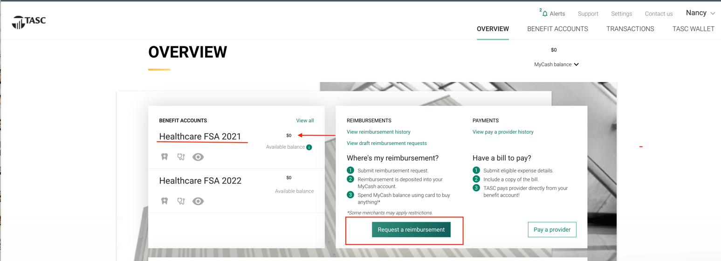

- You will now need to select who incurred the expense. This is applicable if you have any dependents. If you DO NOT have any dependents, select yourself.
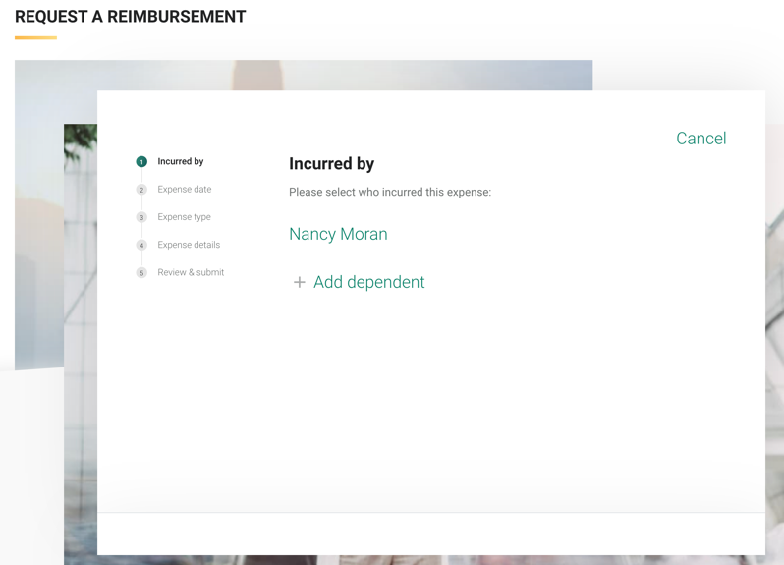

- Select the expense date. You must ensure that the date you select is within 2021, to be imbursed from your 2021 funds.
You can change the dates by clicking on the arrows or selecting on the ‘Enter Date Manually’ option (see screen shot below)

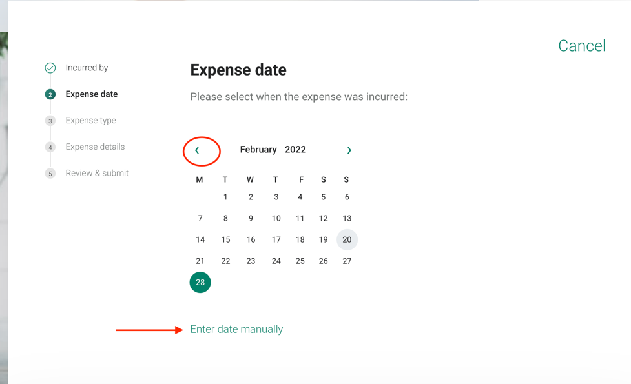

- Select your expense type by clicking on the drop- down menu options. Click on the expense to select it.
- Enter the expense details. You will need to have a receipt, the exact dollar amount and the name of the provider/merchant. (See screen shot)
- To attach the receipt, please select “Attach Verification” and follow the steps to attach necessary information (See screen shot)

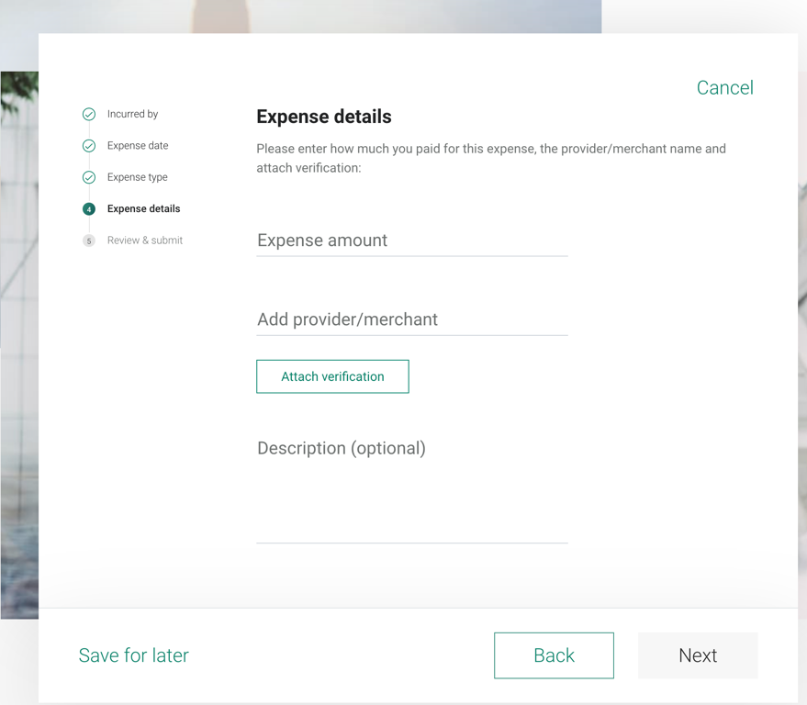

- Once you’ve attached your receipt, click ‘Next’
- Review and ensure all data entered is correct. Verify the date once more and click ‘SUBMIT’

Once you have submitted your reimbursement request, you’ll receive a confirmation email once it’s been approved.

- Once you’ve received the confirmation that the reimbursement was approved, you will now have a ‘MyCash balance’ in your TASC account.

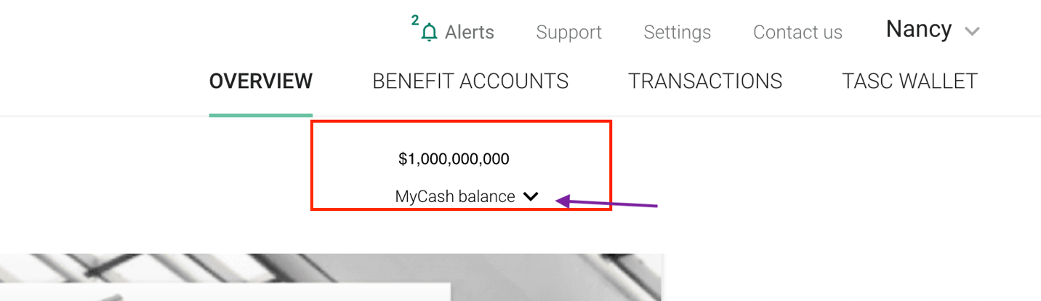
** actual cash balance shown in screen shot is for demo purposes ONLY & not an actual balance

- You can now transfer your balance to your personal bank account OR you can keep it and utilize it by using your TASC debit card

